भारतमौसमविज्ञानविभाग |  | India Meteorological Department
Sunday, 29th June 2025 (8th Ashadha 1947 Saka)
Summary of observations recorded at 0830 hours IST: The Southwest Monsoon has further advanced into remaining parts of Rajasthan, West Uttar Pradesh and Haryana and entire Delhi today, the 29th June 2025. Thus, it has covered the entire country on 29th June, 2025, against the normal date of 08th July (9 days before the normal date of covering the entire India). Under the influence of the upper air cyclonic circulation over southwest Bangladesh and Gangetic West Bengal, another low-pressure area has formed over Northwest Bay of Bengal and adjoining West Bengal and Bangladesh coasts at 0530 hrs IST of today, the 29th June 2025. It then persisted over the same region at 0830 hrs IST of today, the 29th June 2025. The associated cyclonic circulation extended upto 7.6 km above m. s. l. It is likely to move slowly west-northwestwards across North Odisha, Gangetic West Bengal & Jharkhand during next 2 days. The monsoon trough at mean sea level passes through Firozpur, Sonipat, Ayodhya, Gaya, Purulia, centre of the low-pressure area over Northwest Bay of Bengal and adjoining West Bengal and Bangladesh coasts and thence southeastwards to northeast Bay of Bengal. The east-west trough ran from the upper air cyclonic circulation over south Rajasthan & adjoining north Gujarat to the cyclonic circulation associated with the low-pressure area over northwest Bay of Bengal and adjoining West Bengal and Bangladesh coasts across Madhya Pradesh, north Chhattisgarh and north Odisha between 3.1 & 5.8 km above m. s. l. tilting southward with height. An upper air cyclonic circulation lay over north Haryana & neighbourhood and extended upto 1.5 km above m. s. l. The cyclonic circulation over central parts of south Uttar Pradesh persisted at 1.5 km above m. s. l. The low-pressure area lay over Saurashtra & Kutch and adjoining south Rajasthan at 0530 hrs IST of today, the 29th June, 2025. It then became less marked. However, the associated cyclonic circulation lay over south Rajasthan & adjoining north Gujarat and extended between 3.1 & 7.6 km above m. s. l. An upper air cyclonic circulation lay over central parts of north Arabian Sea and extended upto 5.8 km above m. s. l. The cyclonic circulation over northeast Assam at 0.9 km above m. s. l. became less marked.
Day temperatures were markedly above normal (> 5.1°C) at isolated places over Assam & Meghalaya, Odisha and West Uttar Pradesh. appreciably above normal (3.1°C to 5.0°C) at isolated places over sub Himalayan west Bengal & Sikkim, Bihar, Jammu-Kashmir-Ladakh-Gilgit-Baltistan-Muzaffarabad and Tamil Nadu, Puducherry & Karaikal. above normal (1.6°C to 3.0°C) at many places over coastal Karnataka; at few places over Arunachal Pradesh, Nagaland, Manipur, Mizoram & Tripura, east Uttar Pradesh and coastal Andhra Pradesh & Yanam; at isolated places over Gangetic West Bengal, Uttarakhand, Himachal Pradesh, Konkan & Goa, Telangana, Rayalaseema and north interior Karnataka. near normal (-1.5°C to 1.5°C) at many places over Madhya Maharashtra and Vidarbha; at most places over south interior Karnataka and Lakshadweep; at few places over Andaman & Nicobar Islands, Haryana-Chandigarh-Delhi, Marathwada and Kerala & Mahe; at isolated places over Jharkhand, Punjab, west Rajasthan, Saurashtra & Kutch and Chhattisgarh. Yesterday, the highest maximum temperature of 41.4°C was reported at Sriganganagar (Rajasthan).
The Southwest Monsoon has been Vigorous over Andaman & Nicobar and active over Odisha, Jharkhand, Himachal Pradesh and Saurashtra & Kutch. It has been subdued over Assam & Meghalaya, Bihar, Marathwada, coastal Andhra Pradesh, Telangana, Rayalaseema and south interior Karnataka.
Total 328 Station reported rainfall today. Total rainfall is 339.9 cm. Total 315 Station reported rainfall today whose normals are available. Total rainfall is 320.6 cm with normal station total is 286.7 cm.

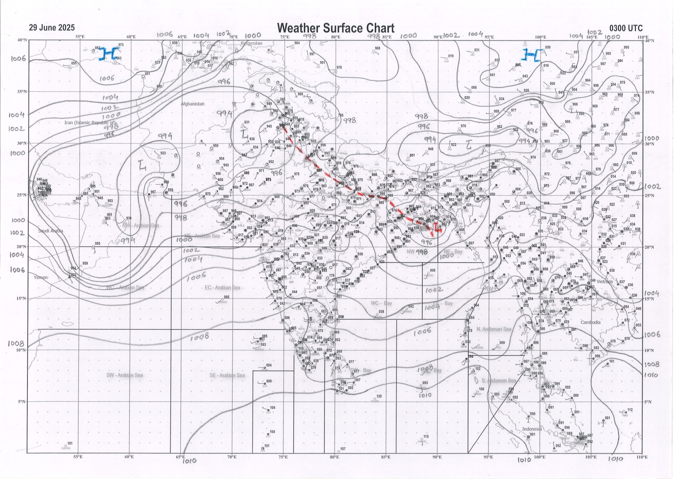 | 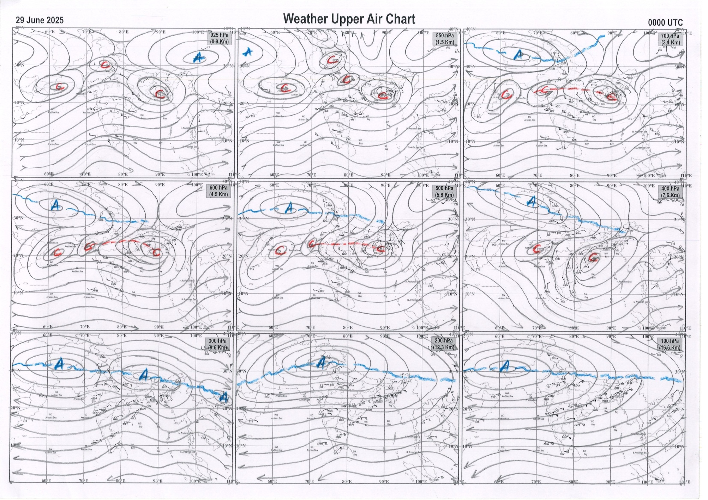
g.1. Analysed surface chart based on 03z observation | Fig.2. Analysed upper air chart based on 00z observation

Dr. Sudeep Kumar B.L.
Scientist ‘D’
CR & S Office, Pune  Issued at 1245 hrs. IST |  | Weather Forecasting Division  CR&S, Pune

Indian regions | Realised rainfall (chief amount in cm during past 24 hrs):
East | most places: Gangetic West Bengal+ and Odisha#  many places: Jharkhand#  a few places: Arunachal Pradesh, Nagaland-Manipur-Mizoram-Tripura and Sub-Himalayan West Bengal & Sikkim  isolated places: Assam & Meghalaya++ and Bihar  Chandua kuliana 32.0, Baharagora 30.7, Ghatsila 29.8, Jamsolaghat 28.3, Bihpuria AWS 13.4, Amfu kharagpur 10.3, Bankura (CWC) 8.7, Bankura 8.1, Angul & Jamshedpur 6.9 each, Ranganadi nt xing 6.6, Kargahar 4.9, Madanpur 4.6, Sevoke 4.4, Jiti t.e. 3.8, Bhalukpong 2.5, Kolasib AWS 2.3, Seppa, N.lakhimpur / Lilabari & Imphal AP 2.1 each, Chottabekra & Darjeeling 2.0 each, Bhagalpur 0.7.
North | most places: Uttarakhand+++  many places: Himachal Pradesh+++  a few places: Uttar Pradesh+, Haryana+++ and Punjab+  isolated places: Jammu-Kashmir and Ladakh, west Rajasthan and east Rajasthan+  Ganganagar 19.3, Narendranagar 16.7, Jogindarnagar 13.5, Kasauli 12.5, Chandigarh 11.9, Chandigarh AWS 11.5, Bharatgarh 11.3, Sundarnagar 9.6, Tajewala 9.4, Dabri fmo 8.9, Bijnor 8.2, Mussoorie 7.6, Kotda SR 7.2, Aligarh 7.0, Balrampur & Ferozpur kvk AWS 6.7 each, Bareilly CWC 6.1, Abu road SR 5.9, Udhampur (iaf) 5.0, Jalandhar 4.4, Unnao tehsil & Mounnt abu 3.7 each, Jalore 3.1, Bhadra 2.1, Kawa AWS 1.7, Kathua 1.6.
Central | many places: Vidarbha and Chhattisgarh+  a few places: west Madhya Pradesh+ and east Madhya Pradesh  Mau 9.0, Chando 7.4, Manawar 6.8, Balaghat-aws 5.7, Chitrangi 5.1, Bhind-aws 4.8, Balrampur 4.7, Gondia AP 3.6, Sidhi (gopadbanas) 3.0, Goregaon 2.6, Gondia 2.2, Durg 1.8.
Peninsula | most places: Gujarat Region+, Konkan & Goa, coastal Karnataka+ and Kerala+  many places: Saurashtra & Kutch and Madhya Maharashtra+  a few places: coastal Andhra Pradesh and south interior Karnataka+  isolated places: Marathwada, Telangana, Rayalaseema, Tamil Nadu+ and north interior Karnataka  Chinnakalar 9.1, Chikhli 8.8, Bantwal 8.6, Valsad 8.2, Shahuwadi & Peermade to 7.2 each, Khergam 7.1, Bhagamandala 7.0, Perumpavur 6.9, Castle rock 6.8, Agumbe emo 6.7, Matheran & Kochi c.i.a.l. 5.4 each, Cincona 5.3, Karjat ARG, Radhanagari & Valparai PTO 5.0 each, Lakhpat 4.8, Talasari 4.5, Panambur 4.4, Kalyanpur 3.9, Porbandar 3.7, Vepada 3.4, Londa & Kottigehara 3.2 each, Paderu 2.8, Mahabaleshwar 2.3, Khanapur 1.5, Govindaraopet & Nagari 1.2 each, Mogullapalle 1.0, Tada 0.8, Soegaon & Haveri PTO 0.3 each, Hadgaon, Visakhapatnam & Tirupati AP 0.1 each.
Islands | most places: Andaman & Nicobar++  isolated places: Lakshadweep◆  Long island 14.2, Port blair 11.6, Maya bandar 9.9, Amini 0.2, Minicoy 0.1.
Table 2. Forecast / warnings (distribution of rain / thundershowers) for 7 days (valid from time of origin upto 0830 hrs IST of next day)
Sr N. |  | Sub-division Name | Day 1 | Day 2 | Day 3 | Day 4 | Day 5 | Day 6 | Day 7 | Sr. No. | Sub-division Name | Day 1 | Day 2 | Day 3 | Day 4 | Day 5 | Day 6 | Day 7
 |  |  | 29 Jun | 30 Jun | 01 July | 02 July | 03 July | 04 July | 05 July |  |  | 29 Jun | 30 Jun | 01 July | 02 July | 03 July | 04 July | 05 July
 | 1 | Andaman Nicobar Islands | W + | W  | W | W | W | F | F | 19 | west Madhya Pradesh | F +  | F+ | F++ | W++ | W +  | W + | W + 
 | 2 | Arunachal Pradesh | F + | F + | F + | F ++ | F ++ | F + | F ++ | 20 | east Madhya Pradesh | F +  | F ++  | F++ | W ++ | W +  | W + | W + 
 | 3 | Assam-Meghalaya | S + + | F + | F + | F + | F ++ | F ++ | F ++ | 21 | Gujarat region | W +  | W +  | W +  | W ++  | W ++  | W + | W ++ 
 | 4 | Nagaland-Manipur-Mizoram-Tripura | F +  | F +  | W +  | W ++ | W ++ | W + | W ++ | 22 | Saurashtra and Kutch | W +  | W +  | W +  | W +  | W +  | W + | W + 
 | 5 | Sub Himalayan West Bengal/Sikkim | F | F + | W + | W + | W | F + | F | 23 | Konkan and Goa | W++ | W++ | W + | W ++  | W ++  | W + | W ++
 | 6 | Gangetic West Bengal | W++ | W+ | W +  | W | F | F +  | W | 24 | Madhya Maharashtra | F ++ | S ++ | S++ | F ++ | F ++ | S + | S ++
 | 7 | Odisha | W# | W++ | W++ | W +  | F ++ | F ++ | W ++ | 25 | Marathwada | S + | S + | I | I | I | I | I
 | 8 | Jharkhand | W# | W # | W ++  | W +  | W +  | W + | W +  | 26 | Vidarbha | S + | S ++ | S++ | F +  | W | F | F
 | 9 | Bihar | S +  | F++ | F++ | F++ | F++ | F++ | F+ | 27 | Chhattisgarh | F +  | S ++  | F++ | F +  | F +  | F + | F + 
 | 10 | east Uttar Pradesh | F +  | W ++  | W ++  | F +  | F +  | F +  | F +  | 28 | Coastal Andhra Pradesh and Yanam | S  + | S+ | S  + | F  | F  | F | S 
 | 11 | west Uttar Pradesh | S ++  | W ++  | W ++  | F ++  | F +  | F +  | F +  | 29 | Telangana | I  | I  | I  | S  | S  | I | I 
 | 12 | Uttarakhand | W ++  | W ++  | W ++  | F ++  | F ++  | F +  | F ++  | 30 | Rayalaseema | I  | I  | I  | I  | I  | I | I 
 | 13 | Haryana,Chandigarh and Delhi | F ++  | F ++  | W + | W + | F + | F | F + | 31 | Tamil Nadu, Puducherry and Karaikal | I  | I  | I | I | I  | I | I 
 | 14 | Punjab | F ++  | F ++  | W + | W + | F + | F | F + | 32 | Coastal Karnataka | W + | W  | W | W+ | W+ | W+ | W+
 | 15 | Himachal Pradesh | F ++  | W ++  | W + | F + | F + | F + | F + | 33 | North interior Karnataka | S  | I  | I  | S  | S  | S | S 
 | 16 | Jammu-Kashmir and Ladakh | S  | S  | S  | S  | S  | S  | S  | 34 | South interior Karnataka | S  | I  | I  | S + | F+ | F + | S +
 | 17 | west Rajasthan | I  | I  | I  | I  | S+ | F+ | F+ | 35 | Kerala and Mahe | F +  | F | F | W | W + | W | W +
 | 18 | east Rajasthan | S  | S  | S +  | F +  | F +  | W++  | W +  | 36 | Lakshadweep | F | F | F | W | W | W | W
Legends: D = Dry I = Isolated S = Scattered F = Fairly widespread W = Widespread #= heavy to very heavy rain at a few places with extremely heavy rain at isolated places +++= heavy rain at a few places with very heavy rain at Isolated places ++= heavy to very heavy rainfall @=Isolated exceptionally heavy rainfall + = heavy rain ●/*= rain or snow ♦ = very light rain ≡=fog= thunderstorm with lightning =Squall / Gusty / gale / strong wind ­ =cold wave/cold day += heat wave/warm night/hot and humid weathe r=Duststorm =ground frost = Hail
Fig. 4: Districtwise warnings for five days for Maharashtra State
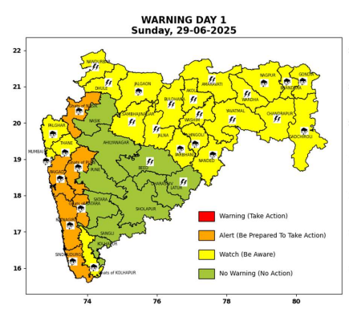 | 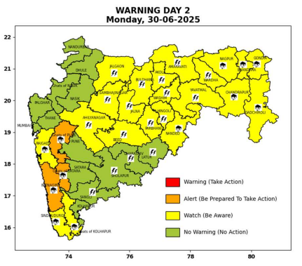 | 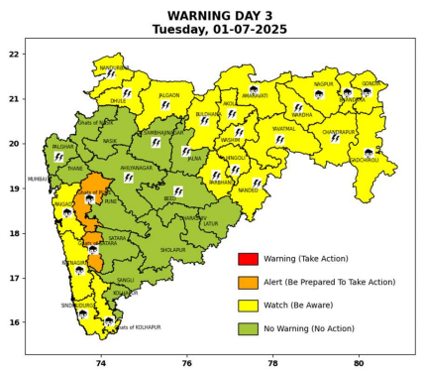 | 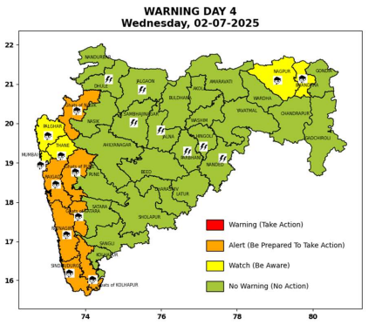 | 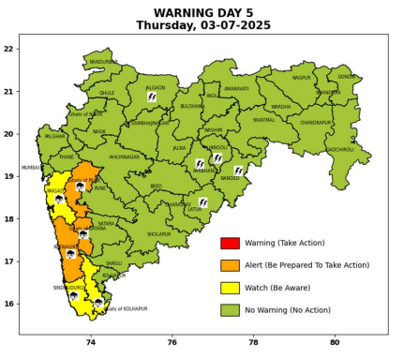

Pune, Lohegaon and Pashan observations at 0830 hrs. IST of Today
 | Temperature (°C) |  |  |  |  | Humidity (%) |  |  |  | Rainfall (mm)
 | Max.  past  24 hrs | Dep.  from  normal | Min.  past  24 hrs. | Dep.  from  normal | Dry  Bulb | At 0830 hrs. IST | Dep.  From  normal | At 1730  hrs. IST of y’day | Dep.  from  normal | Past  24 hrs. | Since  1st June | Dep.  from  normal
PNE | 29.5 | -0.2 | 20.9 | -1.9 | 25.0 | 81 | 0.0 | 65 | -10 | 2.9 | 265.5 | 119.6
PSN | 28.6 | - | 19.5 | - | 23.8 | 92 | - | 75 | - | 4.2 | 306.0 | -
LHG | 31.8 | 0.8 | 22.5 | 1.5 | 26.4 | 76 | -4 | 68 | 0.0 | 3.4 | 248.4 | 152.3

 |  |  |  |  |  |  | Local (Pune and neighbourhood) forecast
Max./Min. Temperature (°C) |  |  |  |  |  |  |  |  | Weather
Date | Pune | Pashan | Lohegaon | Chinchwad | Lavale | Magarpatta | NDA | Koregoan Park
29/06/25 | 29 / 20.9* | 28 / 19.5* | 30 / 22.5* | 29 / 21.0* | 28 / 20.2* | 30 / 22.8* | 28 / 21.9* | 30 / 22.1* | Generally cloudy sky. Light rain very likely. (Heavy to very heavy rainfall at isolated places in ghat areas)
30/06/25 | 29 / 21 | 28 / 20 | 31 / 22 | 29 / 21 | 29 / 21 | 30 / 23 | 28 / 22 | 30 / 22 | Generally cloudy sky. Light rain very likely. (Heavy to very heavy rainfall at isolated places in ghat areas)
01/07/25 | 29 / 22 | 28 / 21 | 31 / 23 | 29 / 22 | 29 / 22 | 30 / 24 | 28 / 23 | 30 / 23 | Generally cloudy sky. Light rain very likely. (Heavy to very heavy rainfall at isolated places in ghat areas)
02/07/25 | 29 / 22 | 28 / 21 | 31 / 23 | 29 / 22 | 29 / 22 | 30 / 24 | 28 / 23 | 30 / 23 | Generally cloudy sky. Light rain very likely. (Heavy to very heavy rainfall at isolated places in ghat areas)
03/07/25 | 28 / 21 | 27 / 20 | 30 / 22 | 28 / 21 | 28 / 21 | 29 / 23 | 27 / 22 | 29 / 22 | Generally cloudy sky. Light to moderate rain likely. (Heavy to very heavy rainfall at isolated places in ghat areas)
04/07/25 | 28 / 21 | 27 / 20 | 30 / 22 | 28 / 21 | 28 / 21 | 29 / 23 | 27 / 22 | 29 / 22 | Generally cloudy sky. Light to moderate rain likely. (Heavy rainfall at isolated places in ghat areas)
05/07/25 | 28 / 21 | 27 / 20 | 30 / 22 | 28 / 21 | 28 / 21 | 29 / 23 | 27 / 22 | 29 / 22 | Generally cloudy sky. Light to moderate rain likely. (Heavy rainfall at isolated places in ghat areas)
Rainfall Distribution |  |  | Rainfall Categories | Rainfall (mm) |  | Cloud condition |  |  |  | Rainfall Intensity |  | Range
Widespread (W) | 76-100% |  | Very Light rain | Trace to 2.4 mm |  | Mainly clear sky |  | 1-2 oktas |  | Light Spell |  | 1 cm/hr
 |  |  | Light rain | 2.5 to 15.5 mm |  | Partly cloudy sky |  | 3-4 oktas |  | Moderate Spell |  | 1-2 cm/hr
Fairly Widespread (FW) | 51 – 75% |  | Moderate rain | 15.6 to 64.4 mm |  | Generally cloudy sky |  | 5-7 oktas |  | Intense Spell |  | 2-3 cm/hr
Scattered (S) | 26 – 50% |  | Heavy rain | 64.5 to 115.5 mm |  | Overcast |  | 8 oktas |  | Very Intense Spell |  | 3-5 cm/hr
isolated (I) | 1 – 25% |  | Very heavy rain | 115.6 to 204.4 mm |  |  |  |  |  | Extremely Intense Spell |  | 5-10 cm/hr
D (D) | No Rain |  | Extremely heavy rain | ≥ 204.5 mm |  |  |  |  |  | Cloudburst |  | > 10 cm/hr
Probability Terms in %: |  |  | Heavy snow | 6.5 to 11.5 cms water equivalent of rain
unlikely | < 25 |  | Very heavy snow | 11.6 to 20.4 cms water equivalent of rain
likely | between 25 50
very likely | between 51 75
most likely | >75
* = realized temperature
Mumbai (Colaba) |  |  |  | Nagpur (AP)
Date 2025 | T max °C | T min °C | Weather | T max °C | T min °C | Weather
29/06 | 31 | 24 | Generally cloudy sky with heavy rainfall. | 34 | 24 | Partly cloudy sky with possibility of heavy rain, thundershowers accompanied with Lightning.
30/06 | 30 | 25 | Generally cloudy sky with moderate rain. | 33 | 24 | Partly cloudy sky with possibility of heavy rain, thundershowers accompanied with Hailstorm.
01/07 | 31 | 25 | Generally cloudy sky with moderate rain. | 32 | 24 | Partly cloudy sky with possibility of heavy rain, thundershowers accompanied with Lightning.
02/07 | 30 | 24 | Generally cloudy sky with heavy rainfall. | 31 | 23 | Partly cloudy sky with possibility of heavy rain, thundershowers accompanied with Lightning.
03/07 | 30 | 25 | Generally cloudy sky with moderate rain. | 32 | 24 | Generally cloudy sky with moderate rain.
04/07 | 31 | 25 | Rain. | 32 | 24 | Rain.
05/07 | 31 | 25 | Rain. | 32 | 24 | Rain.

